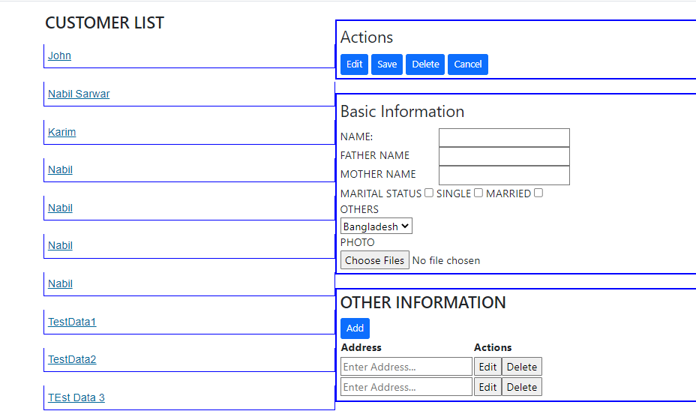

**Customer List Section :**

Lists all the created customer, names will be shown as link, if clicked details of that customer will appear on the left side

**Actions:**

**Edit:**

After clicking link on link Customer **List Section** data will appear on the **Basic Information section and Other Information** section , Edit button will update all edited data**.**

**Add:**

After filling out all the values save will add new customer with address.

**Delete:**

Click link on the **Customer List section,** press delete that customerwillbe deleted

**Cancel:**

All the provided data will be reset from frontend.

**Add: (OTHER INFORMATION SECTION)**

**This will new text box to add new address.**

**EDIT: (OTHER INFORMATION SECTION)**

Will provide text box to edit the address. Other wise it will be read only

**DELETE: (OTHER INFORMATION SECTION)**

Delete will remove a specified address from the front end.

**DbConnectionString Should be provided in CustomerDBContext.cs in Backend project**.

**Add-Migration and Update-Database command should be run.**

**To populate the Country table for drop down**

insert into Country(CountryName) values('Bangladesh')

insert into Country(CountryName) values('India')

insert into Country(CountryName) values('Srilanka')

insert into Country(CountryName) values('Bhutan')

insert into Country(CountryName) values('Nepal')

**Run the app and click on the** Customer Information **portal** **Link**

**Please Referesh the page after adding or deleting data.**